RC tutorial 005 - Alignment with cant - Alignment Coordinate System

========================================================

Revised 2022-11-04

* This tutorial's goal is to teach you the Alignment Coordinate System concept. There is much to read this time! We also touch on Lua formulas in alignments.
* Assumed RailCOMPLETE skills: Previous lessons.
* Assumed railway skills: You know about railway geometry, vertical profile, cant (superelevation), and right-handed coordinate systems.
* Time to spend here: Intermediate: 1 hour. Beginner: 2-3 hours.
* Suggested reading: “2021-05-23_001 EN Introduction to RailCOMPLETE v2021.0”, which can be downloaded from our web pages.
* Notice to users with non-English versions of AutoCAD – see footnote[1].
* This tutorial was prepared using software release 2022.2.0.8 with Norwegian DNA version “NO-BN 2021.a”,” 2021-11-27T21:11:27+01:00;2021.a”.

1. Start AutoCAD with RailCOMPLETE, then open the ‘National Tutorials’ folder and locate the DWG file named after this tutorial. You can either type **RC-OpenNationalTutorialsFolder** or you can locate the button below the RC logo in the upper left corner of your AutoCAD window.
2. The RailCOMPLETE definitions for the Bane NOR network assets measure most lengths in meters and use decimal degrees for presenting angular measures. Cant (superelevation) is measured in millimeters, according to the LandXML 1.2 definitions for metric projects.

NOTE: Some alignment design packages express cant in meters or other units. You may have to scale cant upon importing or exporting alignments with cant data. If you are interested, search for “LandXML 1.2 XSD”.

1. For those who want to draw the alignment from scratch, these are the parameters to use:  
   Et bilde som inneholder tekst, skjermbilde, overvåke, innendørs

   Automatisk generert beskrivelse  
     
   Et bilde som inneholder tekst, overvåke, skjermbilde, innendørs

   Automatisk generert beskrivelse  
     
   Et bilde som inneholder tekst, overvåke, skjermbilde, flat

   Automatisk generert beskrivelse
2. You will also find the alignment as a LandXML file in the Tutorial’s folder.  
   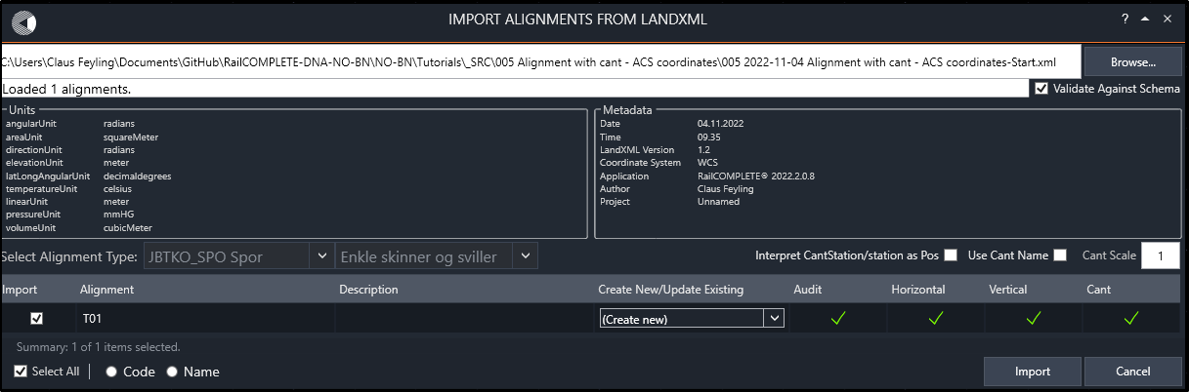
3. Revert to the DWG file. Delete any annotations for geometry and vertical profile. Then show the track in 3D, copy it to the drawing, and switch to ‘Shaded with edges’ rendering. You should see this:  
   Et bilde som inneholder tekst, skilt

   Automatisk generert beskrivelse  
     
   In the following, we will illustrate the Alignment Coordinate System (ACS) in those four different situations.
4. **Case 1:** Straight line, zero gradient, no cant.  
   Insert a “Hairpin” marker object that you will find under the tab for general objects in command **RC-CreatePointObject**. Move it to Mileage = 5. Then activate the **RC-ShowOwnAlignment** tool.  
      
     
   Open the **RC-ManageProperties** tool, slect the hairpin, delete its RelativeElevation formula and then change its relative elevation to 2 meters above the track. Change the object’s Mileage up and down a few meters, then change its relative elevation up and down. Delete the formula for DistanceToAlignment and change its distance to center alignment to -3, which is 3 meters to the left of the alignment’s center line.   
   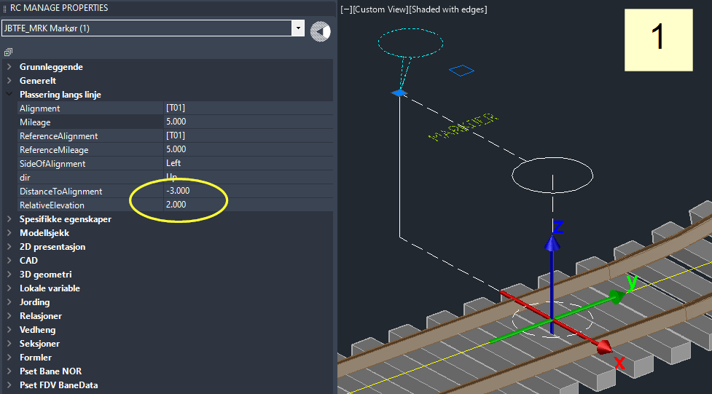  
     
   Notice that the XYZ axis system that appears once the object is selected. This is the ACS at the object’s current position. The red X-axis points to the right, perpendicularly to the alignment’s direction in the XY plane. The Y axis points in the direction of the alignment’s direction. The Z axis always points “straight up”, aligned with the World Coordinate Z axis.

|  |  |
| --- | --- |
| **ACS coordinate** | **Corresponding RailCOMPLETE property** |
| X | DistanceToAlignment |
| Y | LongitudinalOffset[2] |
| Z | RelativeElevation |

**Navigation tip:**  
The user interface in RailCOMPLETE will in many cases allow you to alter a number using the wheel on your mouse in combination with the Ctrl, Alt and Shift buttons on your keyboard. The default step size is 1.  
  
Also note that most numeric input cells accept Lua code, i.e., you may enter any mathematical expression directly, such as ‘25+20’ to change a Mileage from 25 to 45, etc.

|  |  |
| --- | --- |
| **Key combination** | **Step size** |
| **Ctrl + Alt** + mouse wheel | 100 |
| **Alt** + mouse wheel | 10 |
| mouse wheel | 1 |
| **Ctrl** + mouse wheel | 0.1 |
| **Ctrl + Shift** + mouse wheel | 0.01 |
| **Shift** + mouse wheel | 0.001 |
| **Ctrl + Shift + Spacebar** | Snap to nearest integer value |

1. **Case 2**: Straight line, increasing gradient, no cant.  
   Let DistanceToAlignment be -3. Let RelativeElevation be +2. Set Mileage to 15, which is the “Case 2” position as indicated in this document’s first illustration.  
   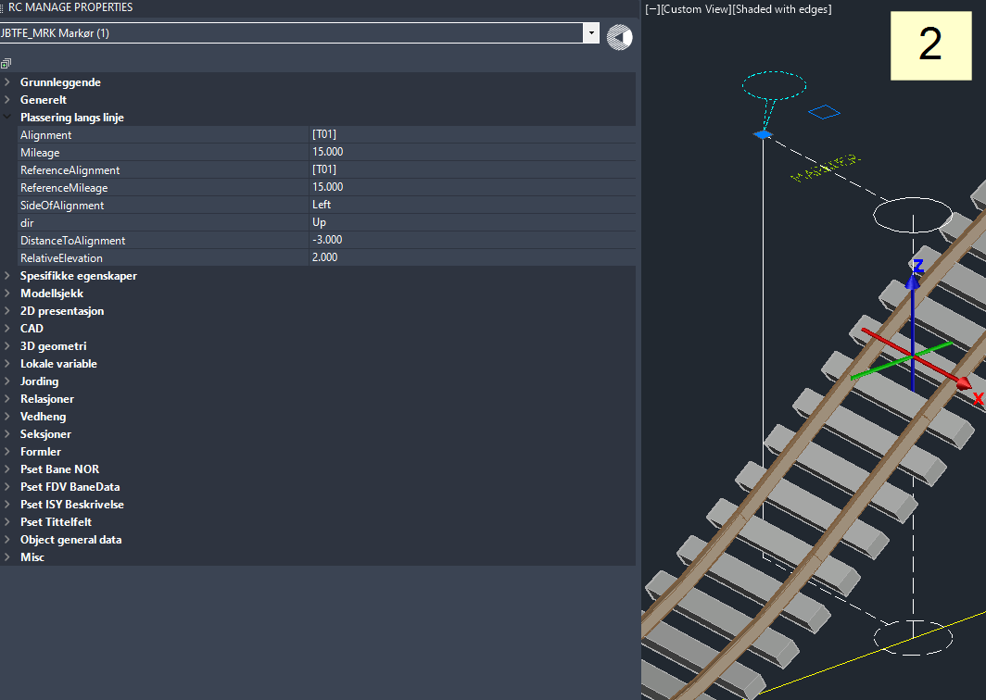
2. **Case 3**: Straight line, decreasing gradient, no cant.  
   DistanceToAlignment = -3. RelativeElevation = +2. Set Mileage to 45, where there is a steep downhill gradient.  
   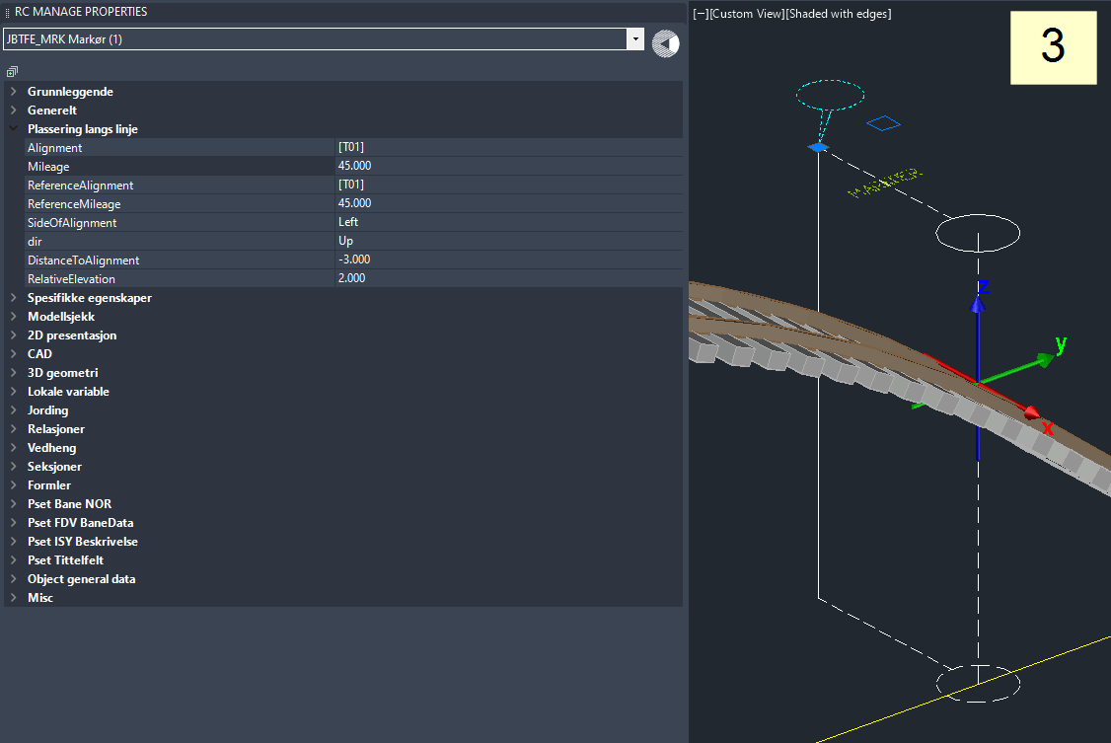
3. **Case 4**: Right-handed curve, zero gradient, significant cant (superelevation), Mileage = 180.  
   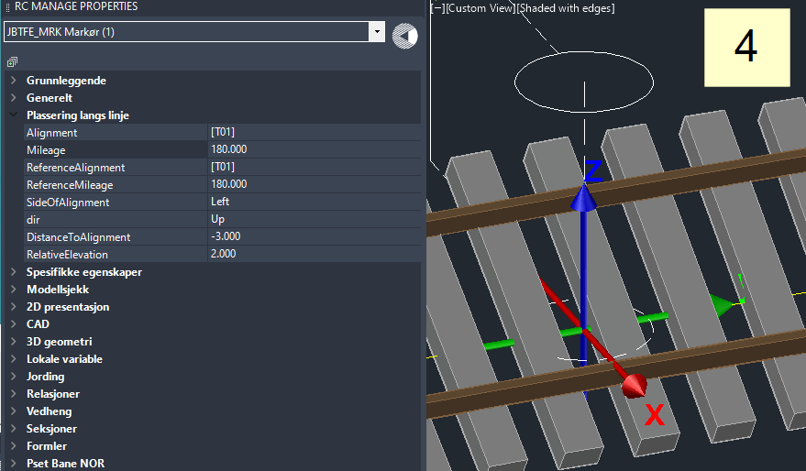

# Further reading

1. **RC-RotateUcsAndView**  
   According to current DNA settings, AutoCAD operates by default in a Cartesian XYZ World Coordinate System (WCS) set to meter [m] unit for each axis, North is 90 degrees and ‘up’, East is 0 degress and ‘right’. Positive direction of rotation is from East towards North.  
     
   To express your object's coordinates in another Cartesian X'Y'Z' User Coordinate System (UCS), use AutoCAD command **UCS** to set the new origin and axis directions, then use **PLAN** or **EXPLAN** to rotate your view so the X' axis points straight right on your screen. A more convenient way for RC users is to right-click, select RailCOMPLETE Rotate UCS and View (command **RC-RotateUcsAndView**)
2. **geoCoord**  
   Point objects possess a property called ‘geoCoord’, inherited from the railML standard. The RailCOMPLETE Property Manager always shows geoCoord XYZ as WCS coordinates – Easting, Northing, Elevation above mean sea level:  
   
3. **Right-handed ACS** *Hint*: Imagine that "Y" is your right-hand index finger which is pointing along the alignment in the increasing mileage direction, and "Z" is your right-hand middle finger pointing straight up. Then "X" is your right-hand thumb, pointing to the right side of the alignment. This is the right-handed ACS.
4. In the RailCOMPLETE Property Manager, Object Manager and Alignment Manager, basic mileage values are expressed in meters (not kilometers).
5. **Lua coding for alignments – a sneak-peek**  
   Select the alignment T01, open the Property Manager, then open the 3D tab and the Offset3D subtab for one of the 3D representations of type “iterated Model 3D”. Make sure it is switched ON (sunshine=Thawed, not snowflake=Frozen).  
   Et bilde som inneholder tekst

   Automatisk generert beskrivelse  
     
   Select the Xoffset3D.X cell, then press F3 to bring up the Lua editor. Enter the following formula:   
     
    **10 * math.cos(3 * 2 * math.pi * _position.Pos / RcAlignment.HorizontalProfile.Length)**  
     
   Et bilde som inneholder tekst, skjermbilde, overvåke, svart

   Automatisk generert beskrivelse  
     
   The ‘_position.Pos’ slider in the Lua alignment editor is a continuous and strictly increasing distance measure along the alignment's horizontal geometry (a 2D curve in the XY plane), a kind of “cursor” that runs from start to end of the geometry. Play with the slider in the Lua alignment editor at the Offset3D.X property and see that the output is a sine wave.  
     
   As long as the property ‘CustomTransformation’ is False, then RC will use its internal machinery when converting the alignment’s geometry, vertical profile and cant profile into 3D rendering.  
   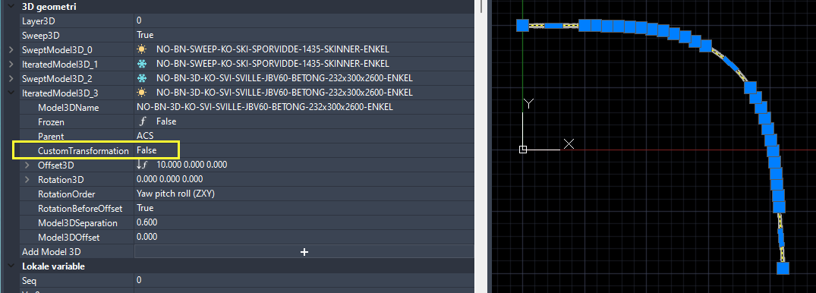  
     
   Set property ‘CustomTransformation’ to True and preview the 3D graphics again. Now the custom formulas for Offset3D and Rotation3D take effect, producing a 3-period sine wave of peek-to-peek amplitude +/-10 in the ACS X coordinate:  
   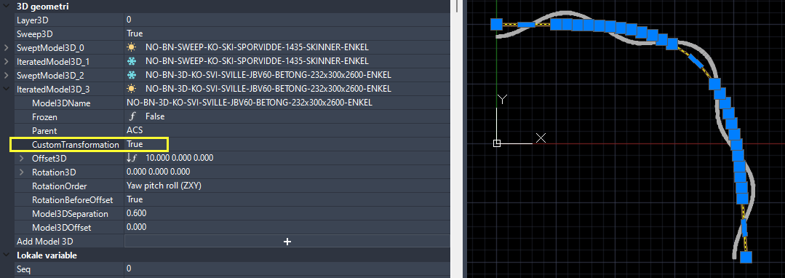
6. **Mileage sawtooth function – chainbreaks – Absolute addressing**  
   The property 'Mileage' that is shown by RailCOMPLETE in the Property Manager is a piecewise linear mapping from _position.Pos to this "railway position name" called "**mileage**" (German: Kilometrierung, French: Point kilometrique ("peh-kah")). The mileage mapping function is often called "chaining". If there are discontinuities in mileage, then these are often called "chainbreaks". With Bane NOR, the mileage is always increasing in the direction away from Oslo Central Station.  
     
   There is a mileage sawtooth function for every alignment. RailCOMPLETE lets you adjust the start value of an alignment’s mileage:  
   Et bilde som inneholder tekst, skjermbilde, overvåke, innendørs

   Automatisk generert beskrivelse  
     
   RailCOMPLETE also lets you introduce chain breaks for the Mileage sawtooth function:  
   Et bilde som inneholder tekst, skjermbilde, overvåke, skjerm

   Automatisk generert beskrivelse  
     
   Annotate the mileage and chainbreaks in your drawing to see the effect of your changes:  
    

Before the chainbreak:  
   
After the chainbreak:  
   
 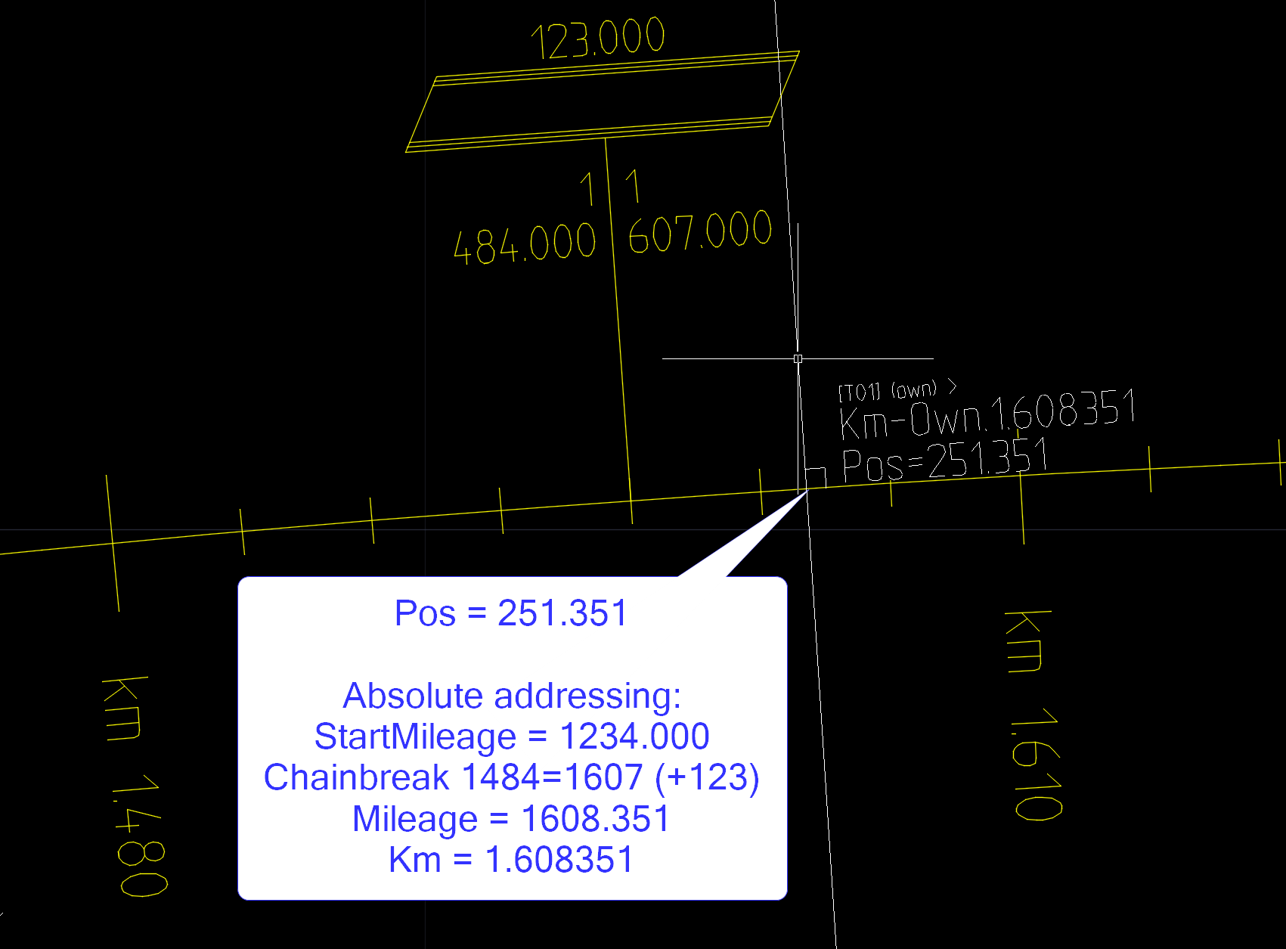  
   
Note that if you enter a number in the Property Manager’s ‘Mileage’ property cell, then there may be several _position.Pos (Pos) locations having this Mileage value, since a sawtooth function is not a generally a bijective function but can have negative jumps (duplicate mileage values) as well as positive jumps (missing mileage values).  
  
In the ISO literature[3] and in IFC[4], using a Mileage sawtooth function for linear positioining is referred to as **Absolute addressing**.

1. **Cant**  
   **Cant**, or **superelevation** is with most railway administrations measured as a vertical uplift of one top-of-rail in relation to the other, expressed in milllimeters [mm]. Cant is basically a signed angle expressing a sleeper’s rotation about the local alignment axis (roll) using the horizontal XY plane as a reference.  
     
   For historical and for practical reasons, cant is measured using a water level device and reading the vertical distance between the two top-of-rails. There is a standard reference **cant gauge** associated with each track gauge, for conversion of cant between millimeters and angle. For **normal gauge** tracks (1432..1438 mm between the two wheel/rail contact points), the standardized cant gauge reference value is 1.5 m. That is, sin(alpha) = h/1500 for normal gauge tracks, where h = cant in millimeters and alpha is the cant angle. The sign of the cant angle is also subject to interpretation. Most track design software packages interpret ‘clockwise cant rotation’ as a positive rotation about the ACS y-axis. Wider gauges use 1600 mm or more as a cant gauge track reference, see the literature on this.
2. **Alignment System in RailCOMPLETE**  
   Select the alignment T01 again, open the Properties Manager’s ‘Alignment’ tab and select the Alignment System row. It should read “Normalspor 1435 mm”, which is the standard for mainlines in Norway. Click to the left of that row to expand it, and you will see the rows ‘Cant Gauge’ (1.5 meters) and ‘Alignment Gauge’ (1.435 meters). The CantGauge value is used when converting cant between millimeters and angles[5]. The AlignmentGauge is used when placing, e.g., axle counters or track joint isolations etc in rails, or when expressing the rail/wheel contact lines in 3D. Think of it – as cant increases, the two rails in a railway track alignment will “creep inwards” towards the alignment axis (as seen from above), without moving the track sideways.  
     
   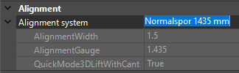
3. Various alignment systems are defined in the DNA. Speak to your local RC agent if you miss one. Some of alignment systems – platform edges, for instance – have 0 as CantGauge. This instructs RailCOMPLETE to interpret the Cant value as a signed Decimal Degrees angle.
4. The last row in the alignment system, QuickMode3DLiftWithCant, is used by RailCOMPLETE when converting an alignment object into 3D graphics. Some administrations interpret the cant as a mere rotation about the alignment axis, but most administrations interpret the cant as a rotation and an upwards translation by half the cant in millimeters. The result is that the lowest rail is always level with the alignment axis Z(s)-value.
5. If an alignment is expressed in 3D with its QuickMode3D set to ‘true’, then RailCOMPLETE considers that the sleepers shall be lifted with half the cant if the alignment’s Alignment System definition says so. In other words, the 3D Offset Z (‘Offset3D.Z’ in Lua) is implicitly replaced by the formula “getAlignmentInfo(_position).Cant/2”, no matter what formula you might have stored for Offset3D.Z yourself.  
     
   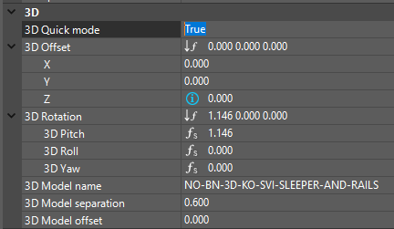
6. When an alignment’s QuickMode3D is set to true, then the Offset3D.X and Offset3D.Y are implicitly set to zero, no matter what formulas you might have stored in them yourself.
7. When an alignment’s QuickMode3D is set to true, then the Rotation3D.X, Rotation3D.Y and Rotation3D.Z formulas are implicitly set to express the rotations you would expect for an object which is installed in a track, such as a sleeper being repeated for every 60 cm or so.
8. In the tutorial DWG file, you will find these values / formulas for the alignment, being used when Quick Mode is false. The ‘NOBN_...’ formulas are stored in the DNA for NO-BN (Bane NOR):  
     
   Offset3D.X 0  
   Offset3D.Y 0  
   Offset3D.Z **NOBN_trk_getLiftFromCant**(_position)  
   Rotation3D.X (pitch) **NOBN_trk_getPitchFromGradient**(_position)  
   Rotation3D.Y (roll) **NOBN_trk_getRollFromCant**(_position)  
   Rotation3D.Z (yaw) 0
9. Activate the RC-Show3DPreview tool  and select the alignment. Play a little with QuickMode3D turned on or off, with values or formulas that you assign yourself to the Offset3D. Place your cursor in the row of interest and press F3 to bring up the Lua editor.
10. When cant is applied to an object, be it a top-of-rail line, a balise, an axle counter, a switch or any other track-bound object, then we rotate the object's lateral position (x,z) around the local ACS y-axis and then translate it upwards by half the superelevation. In this way, both rails will be slightly moved inwards, and the lowest rail's top-of-rail will remain at the alignment's elevation at that position (i.e. at relative elevation zero). Viewed from the positive Z-axis, adding cant to an alignment this way does not change the geometry. If you had instead rotated a track around the lowest rail's top-of-rail, or lowest wheel-rail-contact-point, then the other rail and the centre line would have moved sideways towards the lower rail, which would lead to an unwanted change in alignment geometry.
11. Play a little around with the various alignment annotation tools: RC-ShowAlignmentGeometry, RC-ShowAlignmentProfile, RC-ShowAlignmentMileage, RC-ShowAlignmentName, RC-ShowTwoRails.
12. Copy your track annotations to drawing before you start changing too much. Activate the alignment annotation tools, select the alignment, right-click and select "RailCOMPLETE Annotations => Copy Annotations to Drawing".
13. NOTE: AutoCAD might hide away such annotations from time to time. Using the AutoCAD command AUDIT / _Yes will usually fix this problem, even if AutoCAD reports "Total errors found 0 fixed 0.".
14. Start the Alignment Manager and select the alignment "T01". Check the "Bind to Selection" box.
15. Activate the Alignment / Cant tab. You will see a datagrid displaying the cant details of your alignment.
16. As mentioned above, LandXML and AutoCAD Civil 3D talk about "clockwise cant rotation" and "counterclockwise cant rotation". The mental reference is a 2D profile cut-through of your railway system, a drawing showing the inclined sleepers and tracks with surrounding banks, seen in the direction of increasing mileage. If you think of a superimposed clock's arrows, then lowering the right bank corresponds to increasing time (CW rotation) and vice versa. This is how also RailCOMPLETE interprets cant rotation in LandXML files.
17. NOTE: There is no required definition of CW / CCW reference system in the LandXML 1.2 XSD, so you may have to flip CW/CCW upon import or export of LandXML files to get things right. Or simply set the Cant Scale to ‘-1’ when using RC-ImportAlignmentsFromLandXml.  
    
18. NOTE: If we consider an object rotated with its alignment's cant rotation, expressed in the local Alignment Coordinate System (ACS), then a positive rotation about the local y-axis (which points in the direction of increasing mileage) will raise the left side above the right side, as viewed in the direction of increasing mileage.
19. Check the "Enable Edit" box to allow for modifications in the datagrid.
20. To visualize cant in 3D, you will need to express your railway track using sleepers and rails. Start the RC-Export3D command from the ribbon (under the Import/Export button), and navigate to the ‘Point Objects’ tab. Verify that the references to 3D object libraries are OK (no warning triangles). Deleting all paths (the ‘-‘ minus to the right) will trigger a reset of paths to the current DNA’s settings.  
      
      
    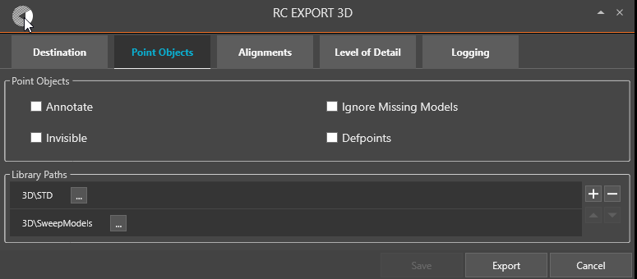
21. Use the ‘Destination’ tab to specify where you want your results to appear. In the ‘Alignments’ tab you may choose to add the alignment axis {X(s),Y(s),Z(s)} and / or the Model Insertion Axis.
22. Select the alignment, locate the ‘Model3DName’ property, Specify one of the standard sleeper & rail object models from the standard 3D library, for instance the object model ‘NO-BN-3D-KO-SVI-SLEEPER-AND-RAILS’. It contains one sleeper and two 60 cm pieces of rail, i.e. a not-so-detailed visualization.
23. Locate ‘Model3DSeparation’ property and verify that it is set to 0.6 meters. This will result in a 60 cm “jump” from one sleeper insertion to the next.  
    Note: The 3D model separation jumps are measured along the 3D alignment axis and not along the XY-plane geometry 2DLength. A track with much up and down will need more sleepers than a flat track. Press the "Export" button to start expressing your BIM alignment as 3D.
24. The last 3D property is ‘Model3DOffset’. It allows you to start at a specified position in the alignment’s XY-plane geometry, i.e. a start value for ‘s’. It should be between 0 and Length2D. In Lua formulas, the Length2D can be accessed from an alignment as ‘RcAlignment.HorizontalProfile.Length’. Set it to half of Model3DSeparation if your 3D object model has its insertion point in the middle. Try to play with different values – see the resulting 3D representation.
25. Each time you have made changes to cant you may visualize them in 3D by selecting the alignment, right-clicking and selecting "RailCOMPLETE Export 3D" (command RC-Export3DUsingCurrentConfig). Your current settings from the RC-Export3D will be used. Alternatively, activate the RC-Show3DPreview tool (which will always return its results to layer 0 in your drawing).
26. Experiment in Alignment Manager with various settings for cant position, can value and rotation. Select and delete your previous 3D exports if you don't want a messy model. For instance, check the effect of using exaggerated cant values and reversing cant rotation directions. The usual maximum cant for railway tracks is around 150 mm. Setting it to 500 mm results in a track with 30 degrees cant.

Please check our website www.railcomplete.com for updates.

Corrections and suggestions are welcome to [support@railcomplete.com](mailto:support@railcomplete.com).

Thank you for using RC Tutorials!

1. Your AutoCAD session has probably been started from a Windows shortcut of the type:  
   “C:\Program Files\Autodesk\AutoCAD 2022\acad.exe” /product ACAD /language “fr-FR”, where “fr-FR” means “French language, France’s version”, or similar, or no language specified (English is the native language for AutoCAD). Native AutoCAD commands may have different names in your language pack, other than the COPY, COPYBASE, FIND etc that you see in our tutorial texts. In order to instruct AutoCAD to accept the native English command name, precede the native (English) command name by an underscore character, ‘_’. For instance: ‘_FIND’ will start AutoCAD’s native ‘FIND’ command even if you are using AutoCAD with the French language pack, where the command in French is called ‘RECHERCHER’.If a command needs an argument ‘ON’, and the French menu says ‘Allumer’, then you can enter ‘_ON’ to instruct AutoCAD to use the option’s native name. Furthermore, the English AutoCAD object selection prompt (command _SELECT) accepts many keyboard shortcuts such as A = (add) add to selection set, R = (remove) remove from selection set and AL = (all) all objects (and many more). These shortcuts are named differently in other language packs. In French they are for instance A=ajouter, S=supprimer, TO=tout. Consult AutoCAD Help in your native language.
2. **LongitudinalOffset** was introduced in 2023. It is zero at the ACS origin. It lets you address coordinates along the ACS Y axis, i.e., extending the alignment’s geometry’s tangent direction up and down from the ACS origin.
3. International Standardisation Organisation, see ISO 19148:2012 Linear Referencing.
4. Industry Foundatino Classes, an exchange language for symbolic infrastructure models and their corresponding expression in 3D as geometrical shapes.
5. In RailCOMPLETE, an AlignmentSystem may have a CantGauge which is zero. If CantGauge is zero, then the Cant value found in the alignment is interpreted as rotation angle in Decimal Degrees.